ANNEX 1
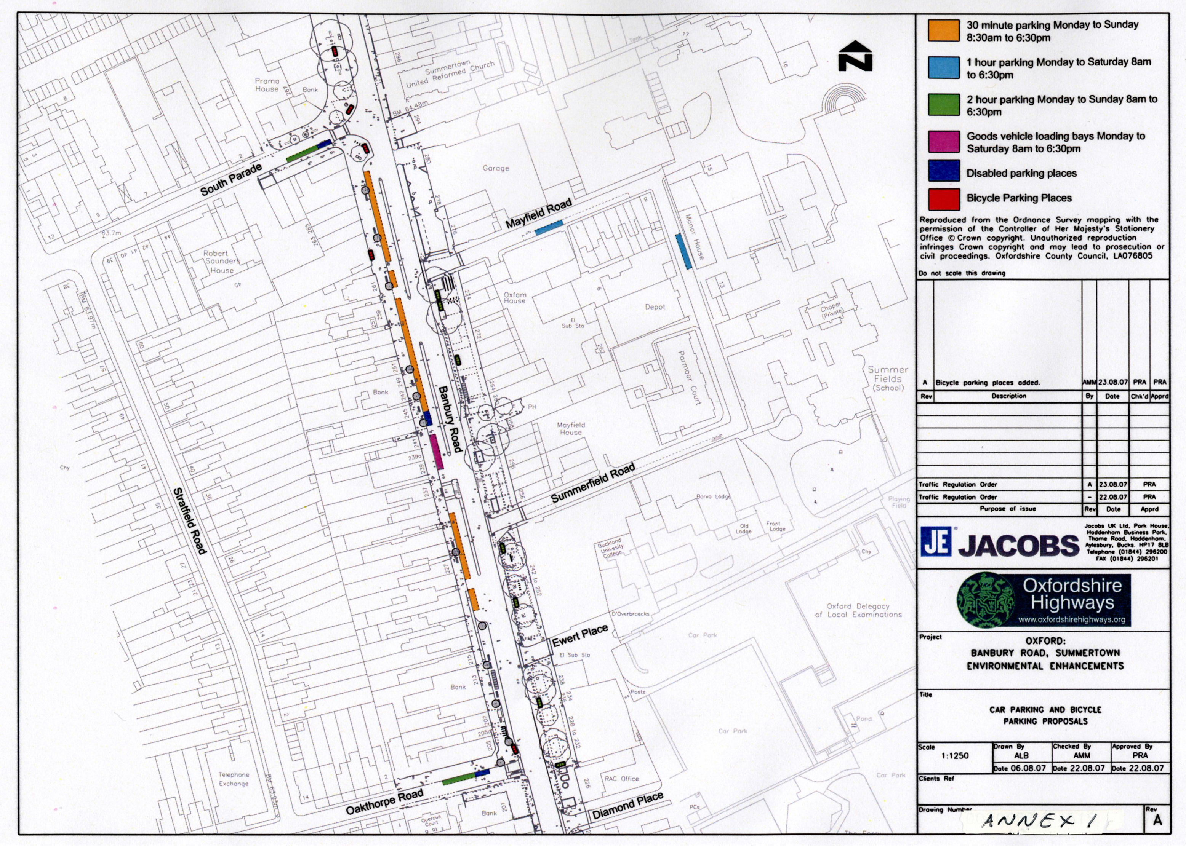
1 hour parking
Monday to Saturday
8am to 6:30pm
30 minute parking
Monday to Saturday
8am to 6:30pm
30 minute parking
Monday to Saturday
8am to 6:30pm
2 hour parking
Monday to Saturday
8am to 6:30pm
2 hour parking
Monday to Saturday
8am to 6:30pm
Disable Parking Space
Disable Parking Space
Disable Parking Space
Goods vehicle loading bay
Monday to Saturday
8am to 6:30pm
Cycle Parking Spaces
Cycle Parking Spaces
Cycle Parking Spaces

